YEAR 9 VISUAL ART

Art Principle: Balance

In a two-dimensional work, balance refers to the way the elements are arranged or captured which creates a feeling of stability in a work. Parts of a composition can be described as taking on a measure or weight of dominance. These are then arranged to achieve stability in the work. The three types of balance are…

SYMMETRICAL ASYMMETRICAL RADIAL

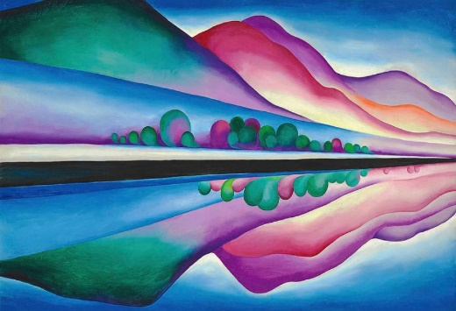 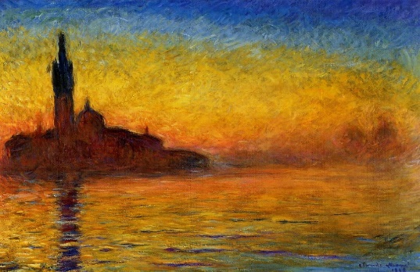 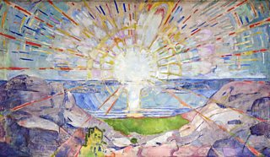

*Symmetrical* Balance has an equal or similar distribution of identical art elements.

*Asymmetrical* Balance has grouping of elements in unequal proportions across the composition.

*Radial Balance* is where the elements of art radiate out from a central point.

Using the Studio Art Process create a landscape painting that demonstrates balance through use of colour and line.

* **Explore:** Research at least 6 examples of landscape paintings, state the type of symmetry is demonstrated and annotate each painting as to how it inspires you.
* **Develop:** Rule up 4 boxes on a A3 piece of paper and produce rough greylead sketches of possible landscape compositions that show one form of balance.
* **Refine:** Select two of your sketches and experiment with creating a ‘mood’ using coloured pencil. HINT – use your researched knowledge of colour symbolism to assist with creating meaning from colour.
* **Resolve:** Select your most effective refined sketch. Draw it lightly onto an A3 piece of paper. Use acrylic paint to complete your artwork.
* **Present:** Decide how you will present your final piece and discuss where you would display your artwork.
* **Evaluate:** State how you create balance and mood in your final painting.

**EXTENSION TASK ONE**: Research a particular artists painting technique and demonstrate the use of this technique in your painting.

**EXTENSTION TASK TWO**: Describe how the colour creates balance and harmony within your painting.